The Mystery of the Death of William Rufus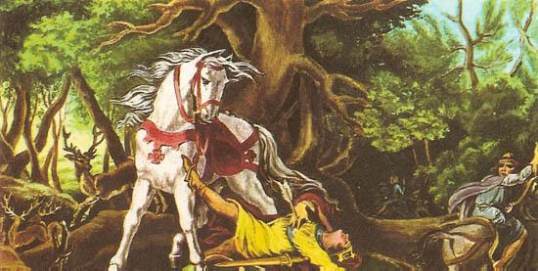
On the sweltering afternoon of 2nd August 1100, King William II - famously known as William Rufus - embarked on a hunting expedition in the dense glades of the New Forest.

Accompanying the king was a small party of noblemen, including his younger brother Henry and a skilled French nobleman named Sir Walter Tyrrell.

William Rufus was an unpopular ruler; his fiery temperament, heavy taxation, and fierce conflicts with the Church had earned him many bitter enemies.

As the sun began to dip below the tree line, the party separated to stalk a herd of red deer moving through the undergrowth.

Sir Walter Tyrrell raised his bow, aimed carefully at a passing stag, and loosed a single hunting arrow into the shadows.

According to contemporary chroniclers, the arrow glanced off the flank of an oak tree, dramatically altered its course, and struck the King squarely in the chest.

William Rufus collapsed to the forest floor, clutching at the wooden shaft before dying in a pool of blood within moments.

Panic instantly erupted amongst the hunting party as the horrific reality of the King's death dawned upon them.

Fearing he would be executed for treason regardless of his intentions, Sir Walter Tyrrell leapt onto his horse and fled toward the coast, escaping to France.

Oddly, Henry did not pursue Tyrrell, nor did he display any grief for his deceased older brother.

Instead, Henry galloped directly to Winchester to secure the royal treasury before riding on to London to crown himself King Henry I.

The abandoned body of the King was left bleeding on the forest floor until a humble local charcoal burner named Purkis discovered it.

Purkis loaded the bloody corpse onto an open wooden cart and transported it slowly along bumpy tracks to Winchester Cathedral for a hurried burial.

The mysterious event was immediately hailed by monks and churchmen as divine retribution for the King's brutal reign and moral failings.

Today, a cast-iron monument known as the Rufus Stone stands in the Hampshire woodland, marking the legendary site where the fatal arrow struck.

Historians continue to debate whether the death was a tragic hunting mishap or a calculated assassination engineered by Henry to seize the throne.

- Source Utility & Chroniclers:
  - Question: Many medieval accounts claimed that William Rufus’s death was divine punishment for his cruelty toward the Church. Why might medieval monks and chroniclers be so eager to push this narrative, and how does it affect the reliability of their accounts?
- Motive & Suspicion:
  - Question: Prince Henry did not pursue Sir Walter Tyrrell for regicide, nor did he mourn; instead, he galloped straight to Winchester to seize the royal treasury. Based on this evidence, what motive might Henry have had for wanting his older brother out of the way?
- Accident vs. Assassination:
  - Question: If you were examining this event as a cold-case detective, what key pieces of physical evidence (such as the arrow deflecting off a tree versus a direct shot) make it difficult to prove whether this was a tragic hunting accident or a calculated murder?

