The Legend of the Angels of Mons

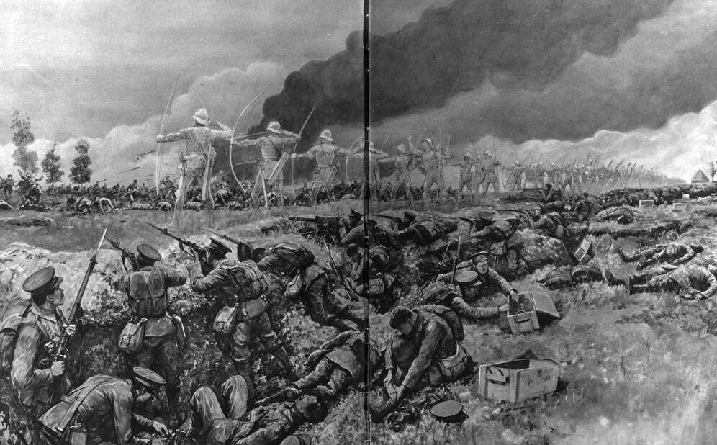
In August 1914, the British Expeditionary Force (BEF) clashed with the German Army at the Battle of Mons in Belgium, marking Britain's first major battle of the First World War.

Outnumbered nearly three to one, the exhausted British soldiers fought bravely along the Mons-Condé canal before being forced into a grueling, week-long retreat under heavy enemy fire.

As rumors of the desperate retreat reached the Home Front, a Welsh author named Arthur Machen published a short fictional story titled 'The Bowmen' in the London Evening News on 29th September 1914.

In his tale, a British soldier facing overwhelming odds calls upon Saint George, prompting a phantom army of medieval English archers from the Battle of Agincourt, which happened in France in the 1400s, to appear in the sky and shower the advancing German forces with invisible arrows.

Although Machen explicitly stated that his story was entirely a work of fiction, many readers accepted it as a true account, and rumors began spreading rapidly across Britain.

Over the following months, the story evolved dramatically as soldiers returning from the front line shared their own strange experiences of the retreat.

Accounts began describing brilliant winged figures, shimmering protective clouds, and angelic guardians hovering between the opposing trenches to block the German cavalry.

Psychologists and historians later suggested that extreme exhaustion, sleep deprivation, and intense battlefield stress could have caused troops to experience vivid hallucinations during the retreat.

On the Home Front, the legend provided profound comfort to grieving families, convincing many that God was intervening directly to protect British soldiers on the Western Front.

Military authorities and church leaders subtly encouraged these supernatural rumors because they boosted civilian morale and reinforced wartime propaganda during a dark period of the conflict.

Today, historians study the Angels of Mons as a fascinating example of how myth, propaganda, and psychological trauma combined during the First World War.

Historical Source Analysis Questions
- Source Analysis: Why might civilians on the Home Front in late 1914 have been so eager to believe Machen's story, despite his public statements that it was fiction?
- Propaganda & Morale: In what ways did wartime authorities benefit from allowing supernatural rumors like the Angels of Mons to spread unchecked?
- Psychological Perspectives: How does understanding the physical and mental conditions of the retreat help explain the experiences reported by soldiers?

