King James I and the Obsession with Witches
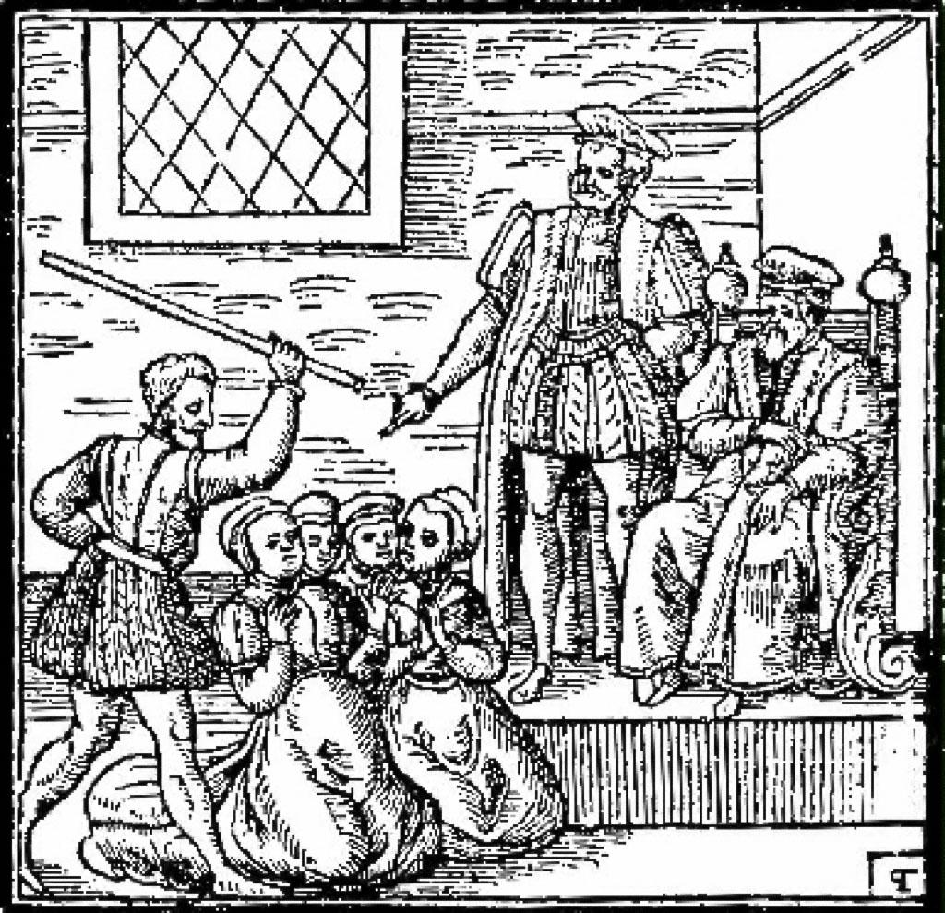
In the autumn of 1589, fourteen-year-old Princess Anne of Denmark set sail across the North Sea to marry King James VI of Scotland, who later became King James I of England.

Her fleet was battered by violent, unexpected storms that drove her ships back toward Norway, forcing her to seek shelter on the Scandinavian coast.

Determined to collect his young bride, King James personally sailed across the stormy waters to retrieve her, experiencing ferocious gales that nearly destroyed his own vessel.

Deeply religious and paranoid, James became convinced that these terrifying storms were not natural events, but were summoned by dark magic intended to murder him.

When local authorities in Copenhagen accused several women of using sorcery to send evil spirits into the sea, news quickly reached the Scottish king.

Sensing a deadly plot against the monarchy, James launched a ruthless investigation in Scotland, leading to the notorious North Berwick Witch Trials of 1590.

Over seventy people were arrested, accused of gathering at North Berwick Kirk on Halloween night to perform unholy rituals and plot the king's demise.

Driven by his growing obsession, King James personally attended the interrogations and trials at Holyrood Palace, watching as suspects were tortured into making confessions.

One accused woman, Agnes Sampson, allegedly confessed under intense suffering that hundreds of witches had baptised a black cat and thrown it into the sea to conjure the tempest.

Frightened by these confessions, James concluded that the Devil regarded him as his greatest enemy on Earth because he was a righteous Protestant monarch.

To educate his subjects and justify the widespread executions, James authored a famous book titled Daemonologie in 1597, detailing how to identify, prosecute, and punish witches.

When James inherited the English crown in 1603, he brought his fierce anti-witch beliefs south, passing harsher laws that made witchcraft punishable by death in England.

His fixation on the supernatural deeply influenced Elizabethan and Jacobean culture, even inspiring William Shakespeare to include the three scheming witches in his famous play, Macbeth.

Today, historians view the trials as a tragic example of royal anxiety, religious turmoil, and gender dynamics combining to create a deadly state-sponsored moral panic.

- Royal Anxiety & State-Sponsored Fear:
  - Question: King James I became obsessed with witchcraft after surviving severe storms at sea. How can personal fear and anxiety experienced by a monarch influence national laws and lead to widespread public panic?
- Torture and Confession Utility:
  - Question: Suspects like Agnes Sampson confessed to bizarre plots under intense physical torment. Why are confessions obtained through torture historically considered unreliable evidence, and why were 16th-century courts so eager to accept them anyway?
- Cultural Legacy & Perception:
  - Question: James authored Daemonologie and inspired Shakespeare to write Macbeth. How did popular literature and royal patronage shape public attitudes toward the supernatural during the Jacobean era?

